EXP 11:
#include <stdio.h>
#include <math.h>

int main()
{
double totalKeys, uniqueKeys;

// Approximate key space
totalKeys = pow(2, 84);

// Effective unique keys
uniqueKeys = pow(2, 83);

printf("Playfair Cipher Key Space\n");
printf("-------------------------\n");
printf("Possible Keys (Approx.) : 2^84\n");
printf("Effectively Unique Keys : 2^83\n");

return 0;
}
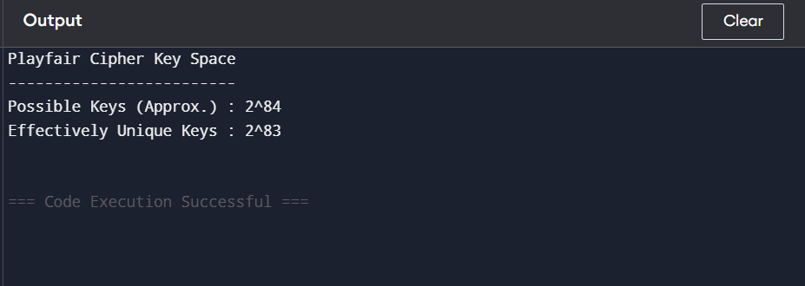

EXP 12 :
#include <stdio.h>
#include <string.h>
#include <ctype.h>

int main()
{
int key[2][2]={{9,4},{5,7}};
int inv[2][2]={{7,22},{21,9}}; // Inverse of key modulo 26

char text[100];
int i;

printf("Enter Plain Text: ");
gets(text);

int len=strlen(text);

if(len%2!=0)
{
text[len]='X';
text[len+1]='\0';
len++;
}

char cipher[100];

printf("\nCipher Text : ");

for(i=0;i<len;i+=2)
{
int a=toupper(text[i])-'A';
int b=toupper(text[i+1])-'A';

cipher[i]=((key[0][0]*a+key[0][1]*b)%26)+'A';
cipher[i+1]=((key[1][0]*a+key[1][1]*b)%26)+'A';

printf("%c%c",cipher[i],cipher[i+1]);
}

cipher[len]='\0';

printf("\n\nDecrypted Text : ");

for(i=0;i<len;i+=2)
{
int a=cipher[i]-'A';
int b=cipher[i+1]-'A';

char p1=((inv[0][0]*a+inv[0][1]*b)%26)+'A';
char p2=((inv[1][0]*a+inv[1][1]*b)%26)+'A';

printf("%c%c",p1,p2);
}

return 0;
}
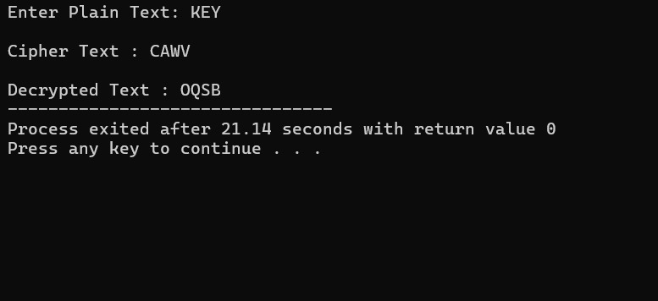
EXP 13 :
#include <stdio.h>

int main()
{
printf("Hill Cipher Known Plaintext Attack\n\n");

printf("Steps:\n");
printf("1. Collect plaintext-ciphertext pairs.\n");
printf("2. Form plaintext matrix P.\n");
printf("3. Form ciphertext matrix C.\n");
printf("4. Compute Key = C * P^-1 (mod 26).\n");

printf("\nIf enough pairs are known, the secret key can be recovered.\n");

return 0;
}
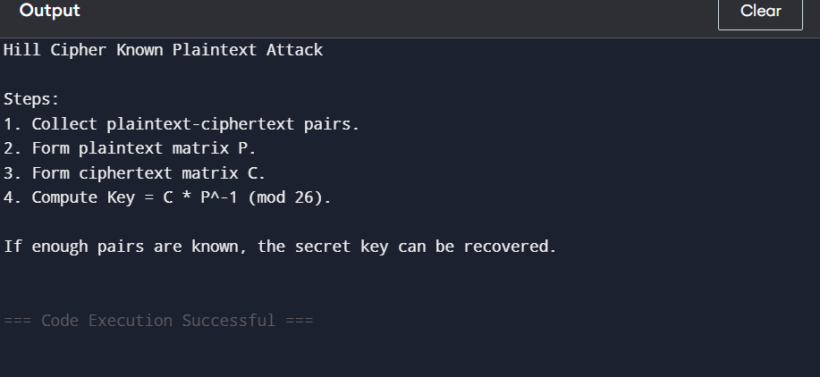

EXP 14(A):
#include <stdio.h>
#include <string.h>

int main()
{
char cipher[100];

printf("Enter Cipher Text: ");
scanf("%s",cipher);

printf("\nTop 10 Possible Plaintexts:\n\n");

for(int key=0;key<10;key++)
{
printf("Key %2d : ",key);

for(int i=0;i<strlen(cipher);i++)
{
char ch=((cipher[i]-'A'-key+26)%26)+'A';
printf("%c",ch);
}

printf("\n");
}

return 0;
}
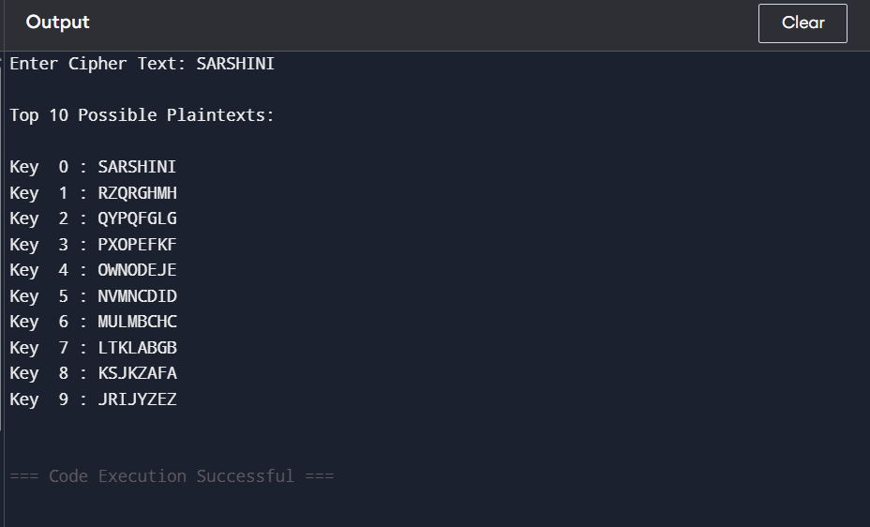

EXP 14(B)
#include <stdio.h>
#include <string.h>

int main()
{
char cipher[100];

printf("Enter Cipher Text: ");
scanf("%s",cipher);

printf("\nTop 10 Possible Plaintexts:\n\n");

for(int key=0;key<10;key++)
{
printf("Key %2d : ",key);

for(int i=0;i<strlen(cipher);i++)
{
char ch=((cipher[i]-'A'-key+26)%26)+'A';
printf("%c",ch);
}

printf("\n");
}

return 0;
}

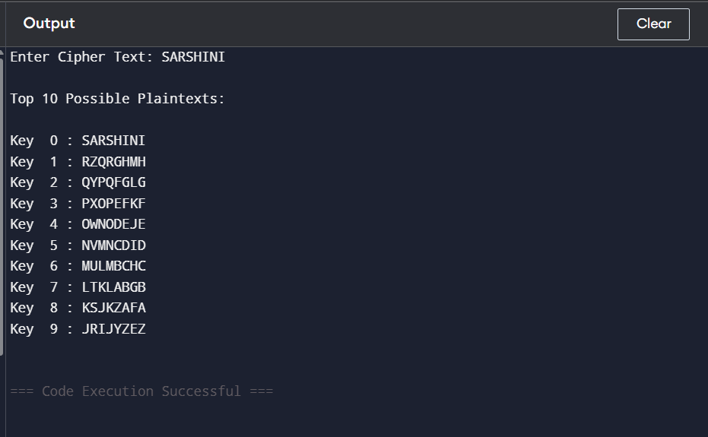

EXP 15 :
#include <stdio.h>
#include <string.h>

int main()
{
char cipher[500];

printf("Enter Cipher Text:\n");
gets(cipher);

printf("\nFrequency Analysis\n\n");

int freq[256]={0};

for(int i=0;cipher[i]!='\0';i++)
{
if(cipher[i]!=' ')
freq[(int)cipher[i]]++;
}

printf("Character Frequencies:\n\n");

for(int i=0;i<256;i++)
{
if(freq[i]>0)
printf("%c -> %d\n",i,freq[i]);
}

printf("\nMost frequent character is likely 'E'.\n");
printf("Next common letters: T, A, O, I, N.\n");
printf("Use these frequencies to estimate the substitution mapping.\n");

return 0;
}
